Weekly Scripture and Sermon Study: History & Context Guide
Matthew 5:14-16 “Light”

History, Culture, & Context

We continue in Matthew chapter 5, with the sections of “Salt” (what we analyzed last week) and “Light”.

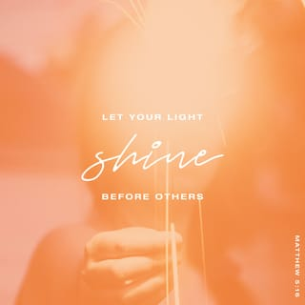
In verses 14-16, we read: “You are the light of the world. A city built on a hill cannot be hid. No one after lighting a lamp puts it under the bushel basket, but on the lampstand, and it gives light to all in the house. In the same way, let your light shine before others, so that they may see your good works and give glory to your Father in heaven.”

We see in John 1:9 that Jesus is the “true light”, and in John 8:12 the “light of the world.” In verse 14 Jesus tells the apostles that they are the “light of the world.” Jesus often employed the use of a metaphor to help make a point in His teachings. Here, Jesus is using the metaphor of light to show the apostles (and the church) radiates the light from Jesus. In this way, the light they radiate shines like a city that sits on top of a hill and thus cannot be hidden from view. Many cities in antiquity were built on top of hills, primarily for protection from the threat of invasion, and their lights could be seen for miles at night.

If we think about some of the writings in the Hebrew Bible, or Old Testament, there are several examples of God calling His people to be a light unto all nations. In Isaiah 42:6 we read, “…I have given you as a covenant to the people, a light to the nations.” Also, in Isaiah 49:6: “It is too light a thing that you should be my servant to raise up the tribes of Jacob and to restore the survivors of Israel; I will give you as a light to the nations, that my salvation may reach to the end of the earth.”
https://www.bible.com/bible/2016/MAT.5.1

In verse 15, we read that “No one after lighting a lamp puts it under the bushel basket, but on a lampstand, and it gives light to all in the house.” Some translations explain it as lighting a lamp and putting it “under a bowl.” The point here is that if you place a light under a bowl, or any type of container, it obscures the light and will ultimately extinguish the flame. We read last week in verse 13 that when salt loses its “saltiness” or essence, it is no longer good for anything. In a similar way, if light is hidden from view, it renders it good for nothing.

As explained in the Book of Matthew Shepherd Notes: When you need a guide through the Scriptures, “Both metaphors [salt and light)] which Jesus uses in this section raise important questions about Christian involvement in society. We are not called to control secular power structures. But we must remain active preservative agents in calling the world to heed God’s standards.” (p. 17)

Questions to Consider

- In what ways can you be a “light” in this world and “…let your light shine before others, so that they may see your good works and give glory to your Father in heaven”? In other words, how can we be a positive influence in this world without drawing attention to ourselves but ensure all glory is given to God?

