Weekly Scripture and Sermon Study: History & Context Guide
John 15:1-17 “Branches”

History, Culture, & Context

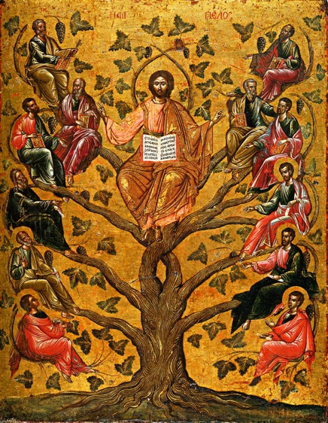
In this section of the Book of John, Jesus is teaching the parable of the vine and branches. The heart of the message is that “I (Jesus) am the true vine” and to be a productive branch that produces fruit you must believe in Christ (the true vine).

In verse 1, Jesus says that He is the “true vine.” For historical context, farmers in this part of the ancient world (Palestine, Asia Minor, Greece, etc.) grew vines for wine making, viticulture and viniculture.

As we have seen throughout the New Testament, Jesus frequently employed the use of parables and metaphors when He was teaching. By teaching through these stories (such as the vine and branches), Jesus invites us to use our imagination, placing ourselves in the story, so that we might better understand the challenging lesson being taught.
From: Christ the True Vine, 16th century Greek icon

Historically, vines are used as metaphors for Israel in the Old Testament. In Psalms 80:8-1-16; Isaiah 5:1-7; 27:2-6; Jeremiah 2:21; Ezekiel 15: 1-6; 17:5-10; and 19:10-14, we see Israel as the grapevine with God as the “vine grower” or the “gardener” that tends to the vine and destroys it if the vine becomes unfaithful (or does not “bear fruit”).

In verses 4-7, Jesus mentions a few different times His command to “remain in Me” or “abide in Me,” in regard to us being able to “bear fruit.” Jesus is the source of our bearing fruit and our identity as a church body. Jesus’ disciples are to bear fruit by being faithful to Him or be “…thrown away like a branch and wither; such branches are gathered, thrown into the fire, and burned.” (Verse 5) Thus, if we abide in Christ, we will bear fruit.

As explained in the Book of John Shepherd Notes: When you need a guide through the Scriptures, “The word (remain) means to stay, abide. Remaining in the vine is not a static or passive activity. In John 15:5, this word is in the present tense, which indicates continuous action. It is the branch that remains and continues to remain in the vine that produces fruit.”

In verses 8-11, we see that bearing fruit is the outward sign of discipleship. This is doing works of love, which are mirrored from the Father’s love in Jesus and Jesus’ love for His disciples. We, as Christ’s disciples and community are to mirror this love through our good works and actions.

Finally, verses 12-17 focuses on Christ’s commandment for us: “…that you love one another as I have loved you. No one has greater love than this, to lay down one’s life for one’s friends.” Here, we see that friendship is defined by Jesus’ love and this love is to be shared by each one of us.

Questions to Consider

- How do you define a relationship marked by mutual love? How does this align with or differ from what Christ teaches?
- What kind of fruit are Christians called to produce?

